**Project 6: Bot to Interact on Chat Environment (Local Environment)**

**Problem Statement:**

Deploy a Bot locally such that interacts to Messages sent by users in a Channel.

**Bot Development:**

* We can Achieve this using Microsoft Bot Framework which is a Software Development Kit (SDK) that helps to create, manage and deploy bots.
* Bot emulator Framework will be used to Interact with Bot through Chat.
* Flask will be used to apply the logic by receiving and sending messages, flask is used because it is light-weight python framework, it can easily Integrate with Microsoft Bot Framework.

**Solution Definition:**

1. Create a Flask project and establish a Python Virtual Environment

and install Microsoft Bot Framework packages.

1. Create the Logic to Receive the JSON message from Chat and Convert it into TurnContext Object and Apply Searching Logic and Return JSON message to the Chat, and store it in app.py.
2. Download Bot Emulator Framework and Pass the LocalHost Address as Bot URL.

**Procedure:**

**1.Setting Up the Flask Project:**

1. Go to your Desired Location and Create a Folder.
2. Go inside the Folder and open cmd and enter ‘python -m venv venv’, this creates a virtual environment inside your folder.
3. Activate Virtual Environment ‘venv\Scripts\activate’.
4. Install the Required Packages,
   1. pip install flask botbuilder-core botbuilder-schema aiohttp.
   2. pip install botbuilder-dialogs botbuilder-ai
5. Create a File app.py to apply logic to your bot.
6. After Saving app.py , open terminal and type ‘python app.py’ to run the Flask project with specific port.

app.py:

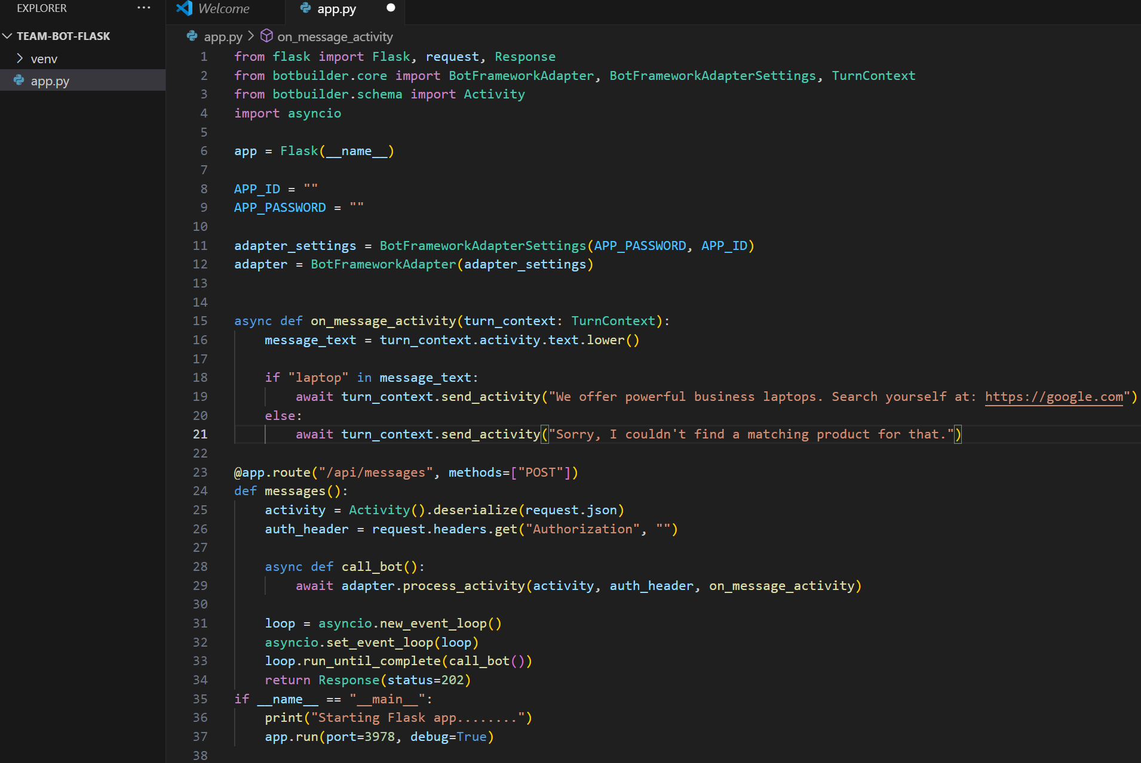

Terminal:

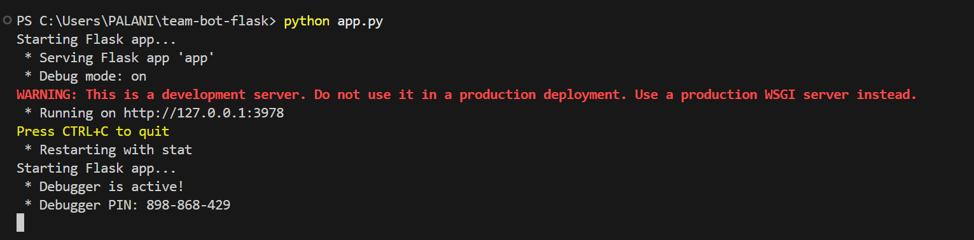

**2. Setting Up Bot Emulator:**

1. Download the Bot Emulator from official Download Page:

<https://github.com/microsoft/BotFramework-Emulator/releases>.

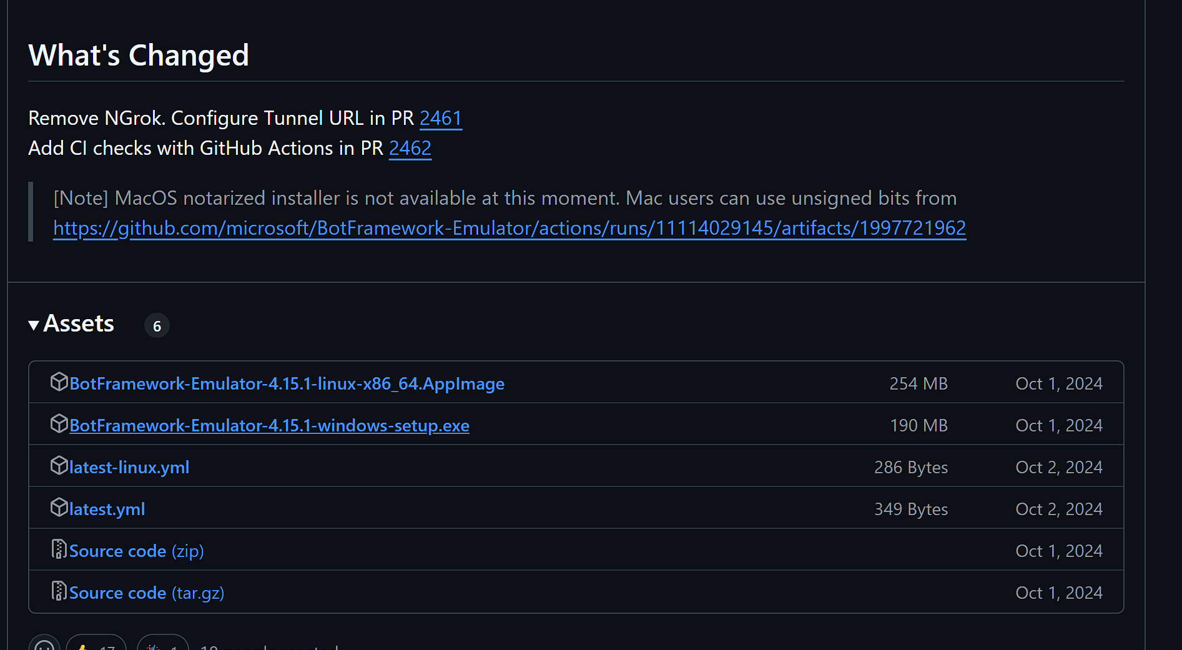

1. Download the latest Version according to the OS you are using.
2. Complete the Setup Process and Launch the Emulator.

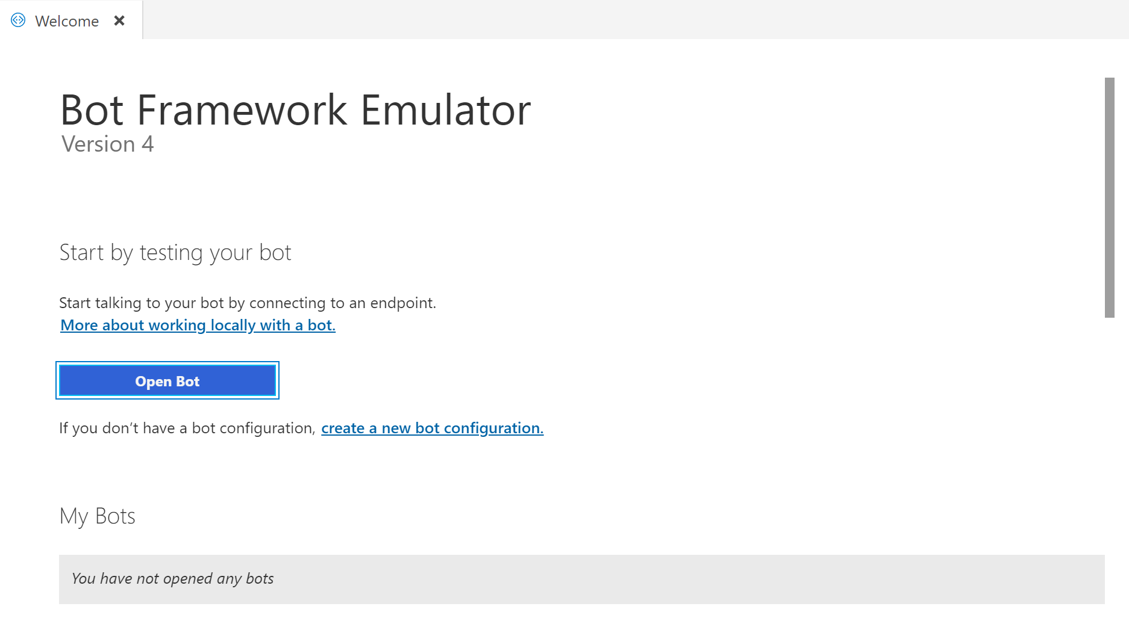

1. You will see an option like ‘Open Bot’, Click it.

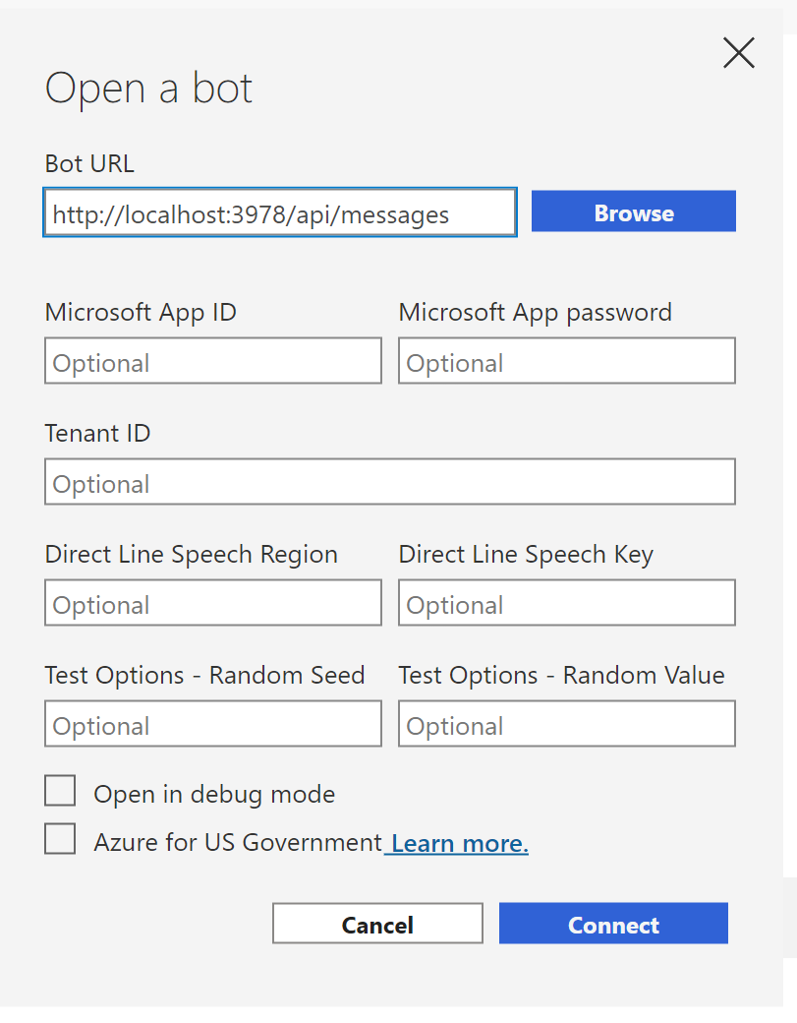

1. It will ask for Bot URL, enter your Local Host URL there and leave other, this is because we are running in local host. Click Connect.

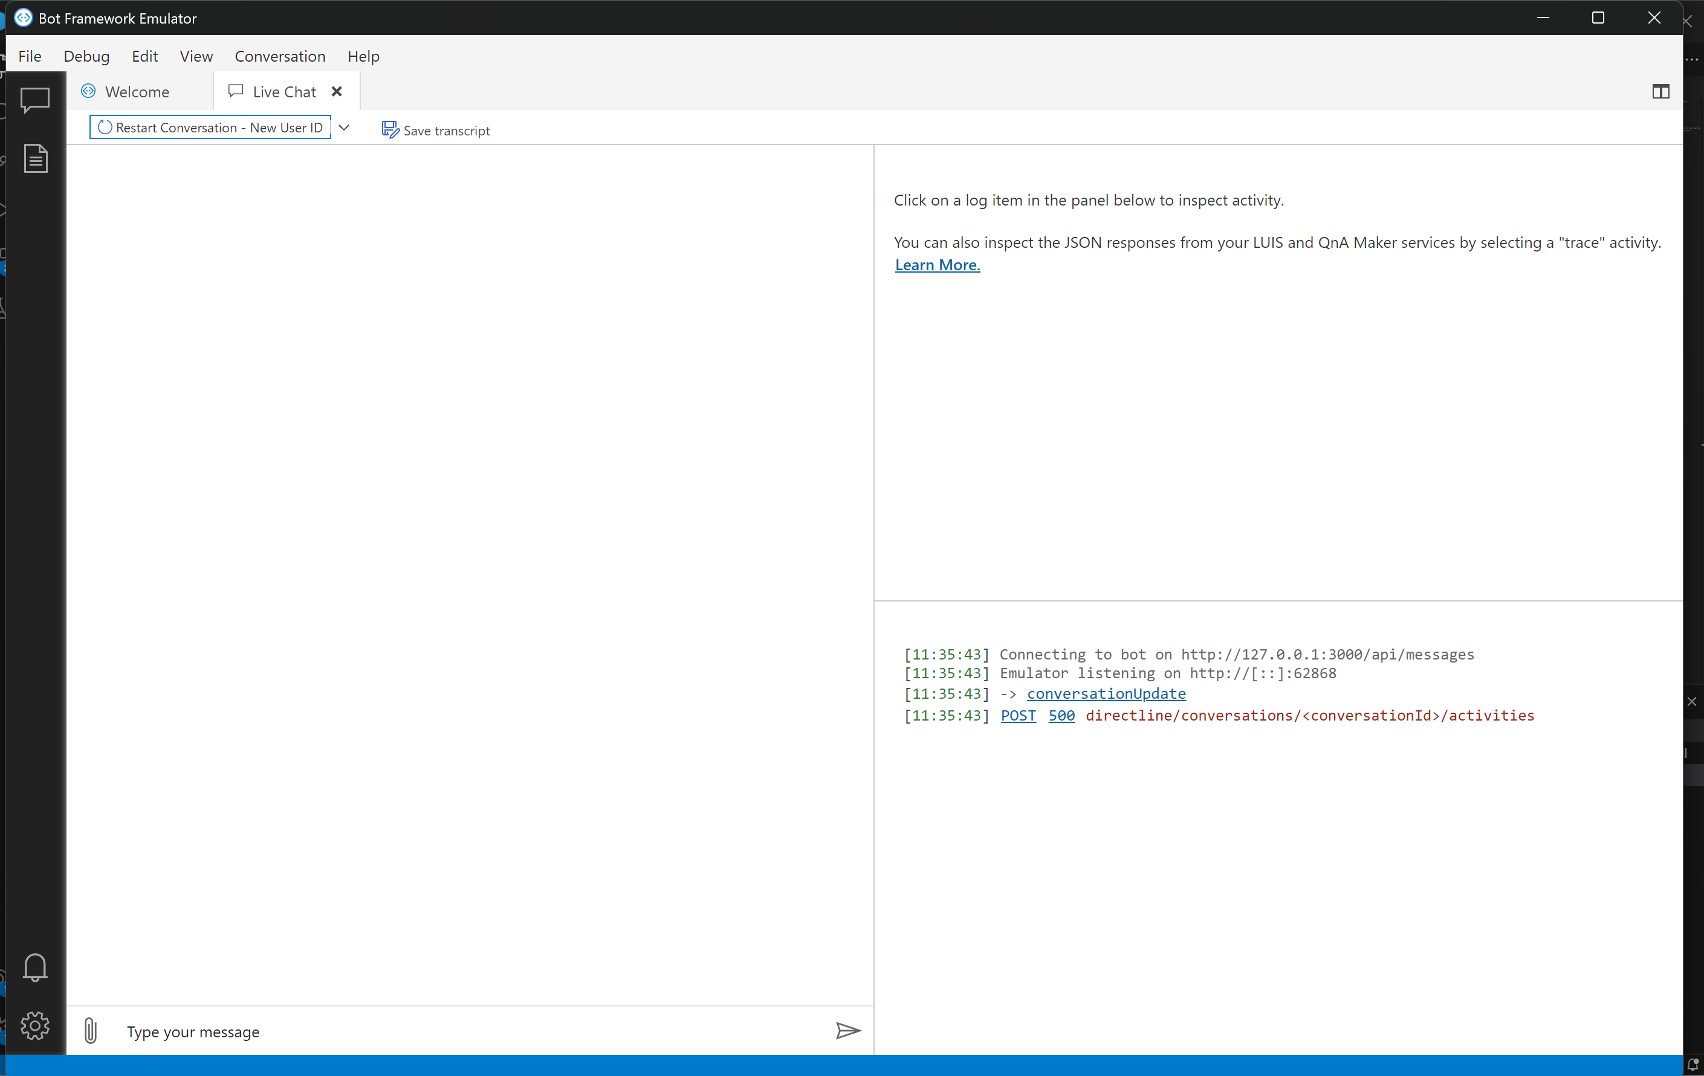

1. Make sure Flask project is running, and then you will see this dashboard.
2. Now you Can Type Message In the bottom left.

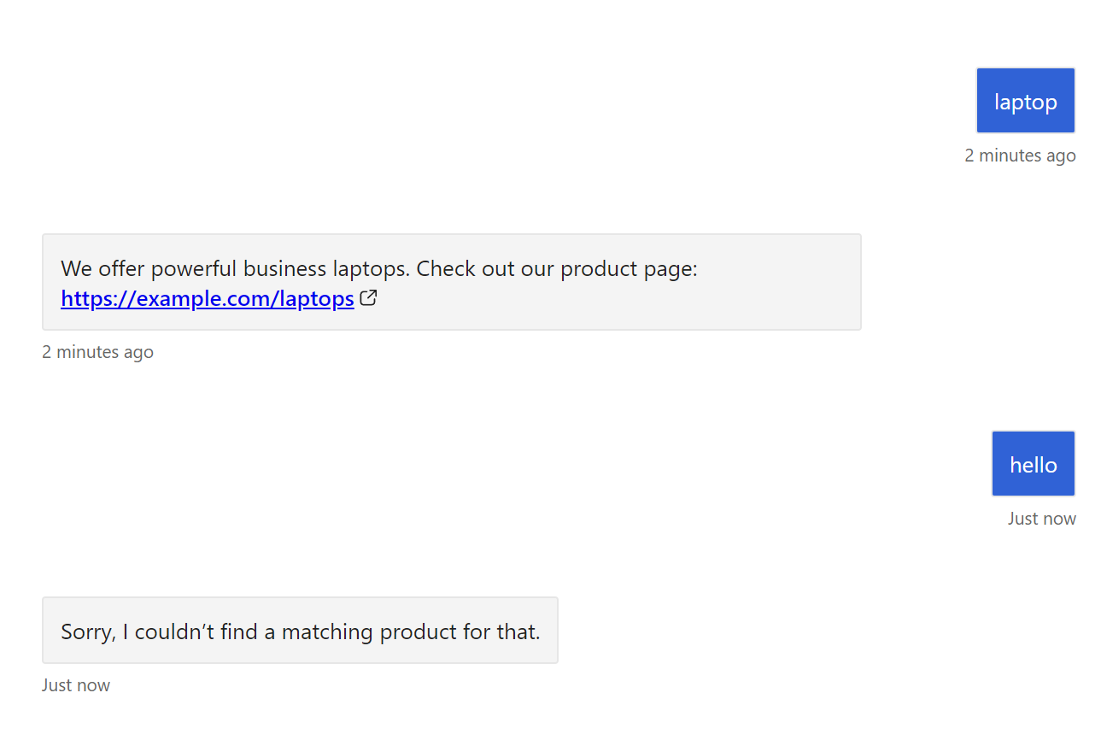

1. If you type ‘laptop’, it will reply with a message. If something else is sent, it will reply with Not found message.